**FUNCTIONAL AND TECHNICAL COMBINED DOCUMENTATION**

**Page (47): Edit your Portfolio (Front End Url:** <http://localhost:8100/page47/Page4>7)

The Heading in the picture should be “Edit your portfolio” instead of “Create a New Account”. It was all by mistake.

**Functional Picture:**

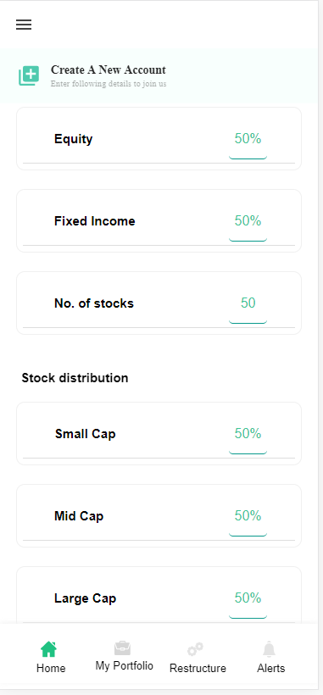

**Technical Explanations (Front End and Back End):**

**In Page47.tsx, we are calling following two API’s:**

1. FinalDivesificationAPI: see view.py python file from BackEnd

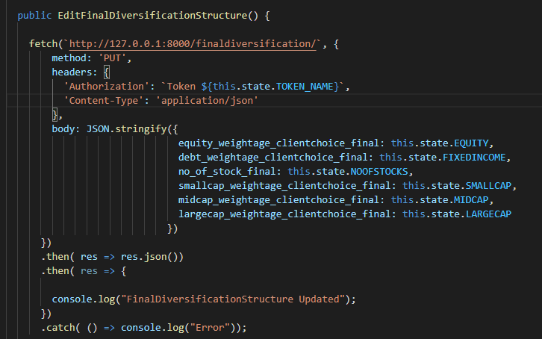

**As you can see above, there are two urls:**

* [**http://127.0.0.1:8000/finaldiversification/**](http://127.0.0.1:8000/finaldiversification/) **--🡪** FinalDivesificationAPI

Here we are using **PUT** Api to update the **FinalDiversificationStructure** model

through **put** method of **FinalDivesificationAPI** class in the Back End.

**In** FinalDivesificationAPI, we are updating the data of **FinalDiversificationStructure** model.

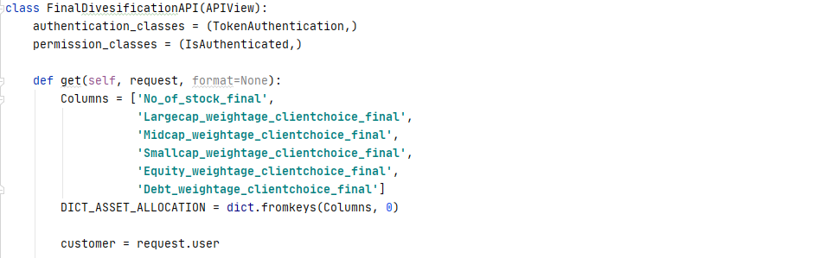

As you can see, we are updating the data in **FinalDiversificationStructure** database according to the user.

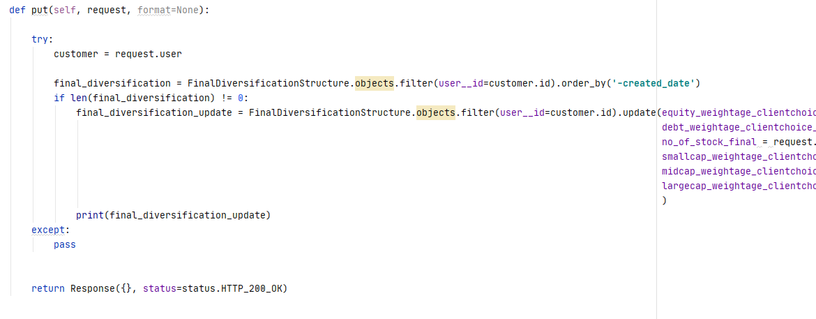

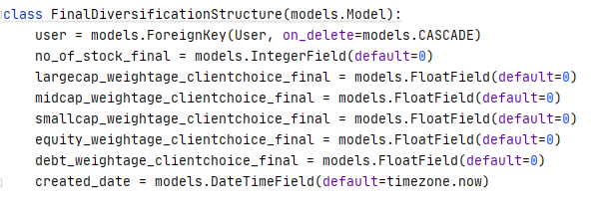

**The above given code snippet is our FinalDiversificatioStructure Database model.**